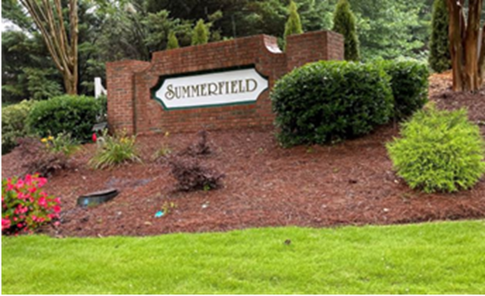
Summerfield Times
Community Newsletter
www.summerfield-hoa.org
2021 Summer Edition

Friends & Neighbors, we hope you all are having an enjoyable summer. This year we were not able to make any adjustments to the time the pool opened or closed but anticipate being back in full swing including our annual family movie nights next summer!

Join us for the Back-to-School Bash in the pool parking lot Saturday, August 28th, from 2:00pm – 6:00pm
(Rain date will be the following week if necessary)
Family fun, refreshments, and the children’s favorite
**Bouncy House*
The Summerfield Annual HOA Meeting will be at the pool parking lot on October 30th, 2021, 3:00pm – 5:00pm.
Refreshments will be available

Remember your Votes count, so vote early!
We look forward to seeing you at these events!

Summerfield Times
Community Newsletter
www.summerfield-hoa.org
2021 Summer Edition

Summerfield Thoughts  Be safe ~ follow CDC safety guidelines  Have deliveries & mail picked up by someone you trust when you are not at home  Curb your dogs & watch your cats! | Keeping up with Community Covenants & Guidelines  Keep your property looking good; it is great for the neighborhood & community home values  Maintain lawns all seasons, pressure wash homes & driveways when needed  Making exterior changes to the property; fill out a modification request first!
Drivers ~ Slow Down!!!  Our Children are back at school  Parking on the streets is prohibited  STOP – Neighbor’s driveways are NOT a turnaround; it is private property!  Always pay Attention ⁓ Drive Safely | Community Corner  Join us as part of the Summerfield HOA Architectural & Social Committees, etc.  Property Management for Summerfield  All-In-One Community Management  678-363-6479 or  customerservice@allinonemgmt.com
Enjoy the rest of the summer and stay safe! Summerfield Board of Directors

